NUID: 002773368

Name: Yuxuan Cheng

This is the report for CSYE7200 assignment – functional – composition.

In this assignment the function class is not hard to complete by verifying its type; besides this project used implicit keyword and jsonFormat (+number) method from the spray-json library. Then the toJson.convertTo method is applied to acquire the result for compare.

The screenshots are shown as followed:

For Movie.scala.

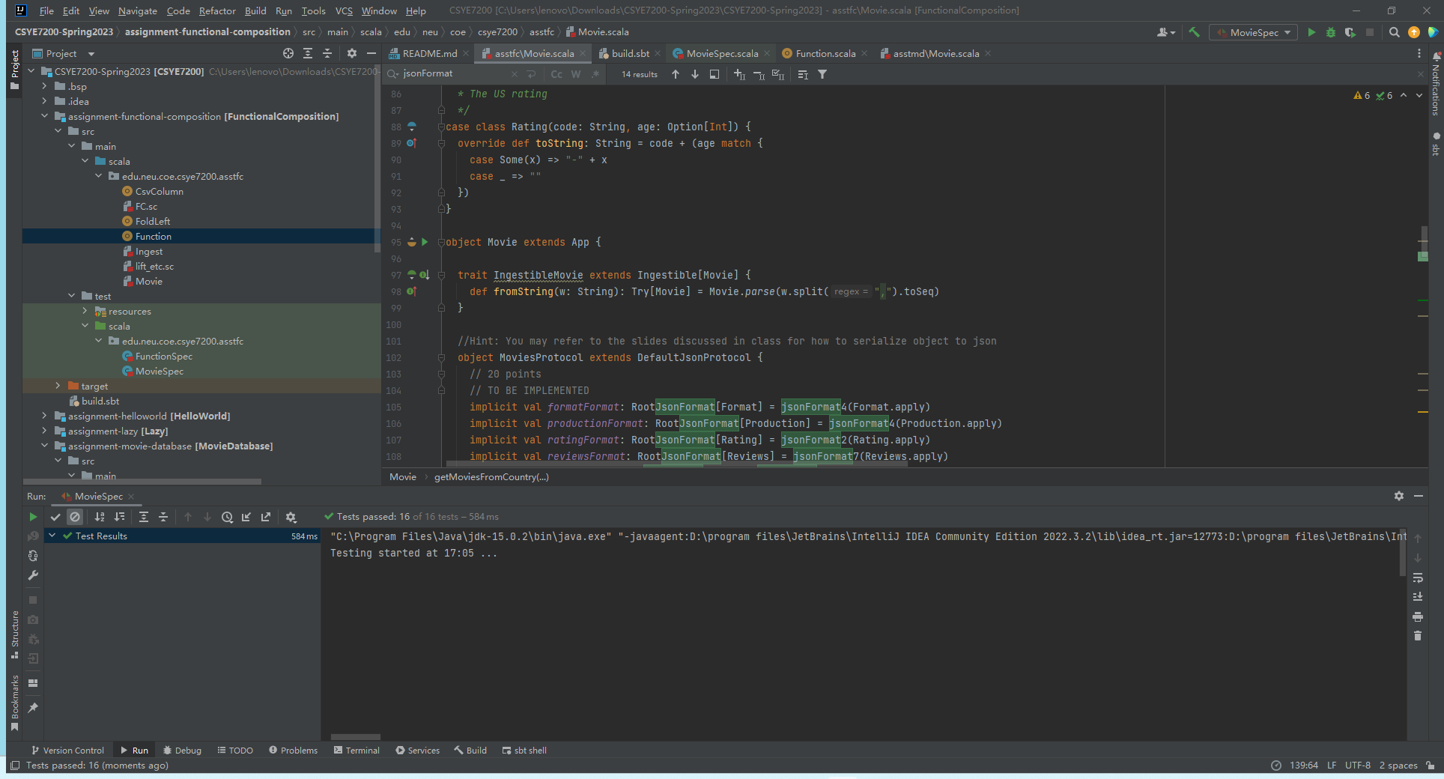

For Function.scala.

